Field Description Description
MSH|^~\&|GZ-8 Plus|123456789v|||20230131110420||ORU^R01|202301311104200001|0|2.3.1|||AA||CHA|UTF-8
Sequence | Value | Description | Composition
1 | GZ-8 Plus | Instrument Type
2 | 123456789v | Instrument Serial Number
3 | 20230131110420 | Message Generation Time
10 | 202301311104200001 | Message Generation Time + Message Number

OBX|0|STR|DATA||20220801002^47^dff^7^7^^^1^1^20220801^204017^110^110^110^110^110^110^110^110^110^110^110^110^118^118^130^136^139^139^140^141^141^151^157^160^163^163^163^163^163^163^163^173^177^182^183^183^183^185^185^185^41^0^0^0^0^0^0^0^0^0^0^0^0^0^0^0^0^0^0^0^0^0^0^0^0^0^0^0^0^0^0^0^0^0^0^0^0^0^0^0^0
Instrument Type | Value | Description | Composition
1 | 20220801002 | Unique number of the data in the instrument, instrument database KEY value | Composition: date + number of the day the experimental data was generated (001-999)
2 | 47 | Project ID | The correspondence between project ID and project name is shown in the attached table “Project ID and Name Correspondence Table”.
3 | dff | Sample ID | The sample ID is set at the beginning of the instrument.
4 | 7 | Experimental channels（hole_num） | 0-15 //0-7 for fam; 8-15 for hex
5 | 7
6 | None | Patient ID
7 | None | Remark
8 | 1 | Channel Type | The range of values is 1-2; 1 stands for fam 2 stands for hex;  Used to distinguish whether the check sample experimental data is hex fluorescence data or fam fluorescence data;
9 | 1 | Result | 0-4 //0 for positive 1 for negative 2 weak positive 3 strong positive 4 critical
10 | 20220801 | Experiment completion date | yyyyMMdd
11 | 204017 | Experiment completion time | hhmmss
12 | 110^…^185(40data) | Amplification raw data
13 | 41 | CT value | 0-41 41, 40 and 0 are abnormal data, others are normal data
14 | 0^…^0 (40 data) | Amplification Fitting Data

Sample ID:

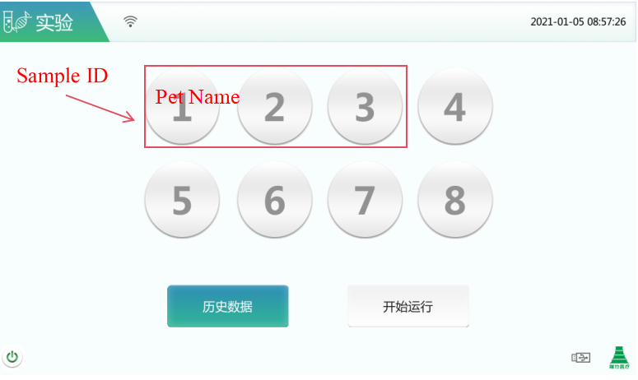
Fig. 1 Sample ID
Experimental channel (hole_num): the value range is 0-15; 0-7 corresponds to the fluorescence data collected by the fam channel of 1-8 holes, respectively; 8-15 corresponds to the fluorescence data collected by the hex channel of 1-8 holes, respectively;
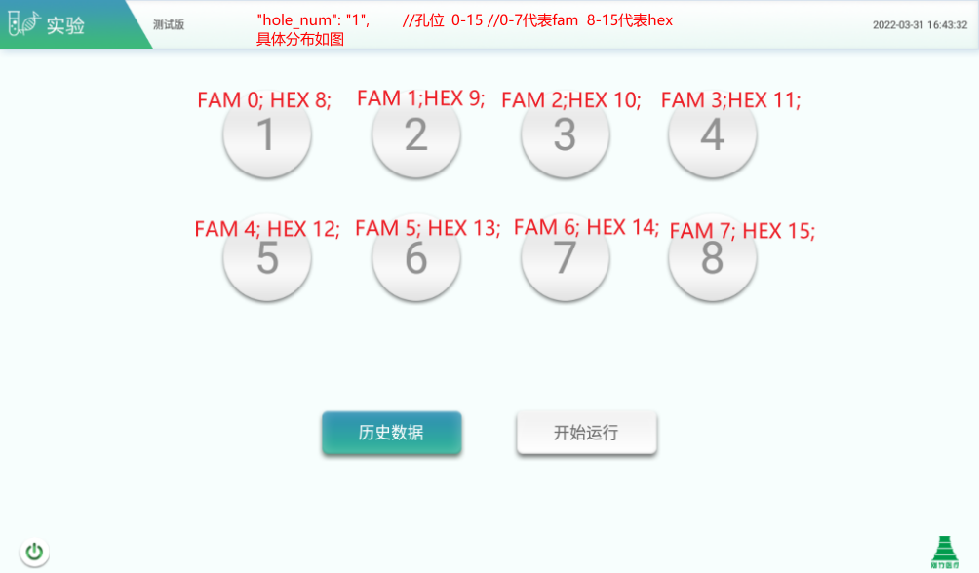
“hole_num":"1", //hole 0-15//0-7 represent fam 8-15 represent Specific allocations are shown in the figure:
Fig. 2 Experimental channels
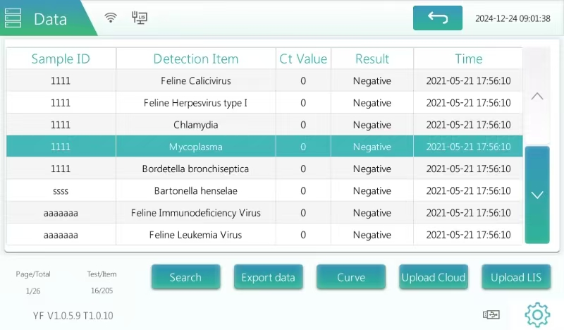

Version Description:
Version 1.2: Modified the description of “experimental results”: added types 2-4 (weak positive, strong positive, critical).

